### Talk and Learn: Dinosaurs Topic Summary

### Things to Talk About and Find Out:

* What do you know about dinosaurs?
* How would you describe…?
* Are all dinosaurs the same?
* What types of dinosaurs can you name?
* What would you like to find out about dinosaurs?
* What do you think happened to dinosaurs?
* How do we know about dinosaurs?
* What do you think it was like when dinosaurs were alive?
* What did dinosaurs eat?
* What is a fossil? Have you ever seen a fossil?
* What body parts can you name on a dinosaur?
* Can you show me how a dinosaur might have moved?
* Where might dinosaurs have lived?
* I wonder what you notice about these pictures.

# Topic Words

### First, I can try to use these words:

### Dinosaur, Tyrannosaurus rex, Stegosaurus, Triceratops, Pterodactyl, Velociraptor, Allosaurus, Apatosaurus, Ankylosaurus, mouth, teeth, tail, legs, horns, scales, claws, walk, run, swim, fly, eggs, bones.

### Then, I can try to use these words:

Fossils, extinct, herbivore, carnivore, omnivore, volcano, reptile, prehistoric, palaeontologist, diet, habitat, predator, triassic period, jurassic period, cretaceous period, artefact, skeleton.

### Diary dates and special days:

## Things I Will Learn

I can name some dinosaurs.

I can name some body parts of dinosaurs.

I can talk about what dinosaurs used to eat.

I can talk about how we know about dinosaurs.

I can talk about some ways that dinosaurs are the same and some ways that they are different.

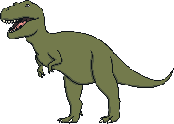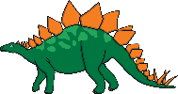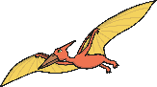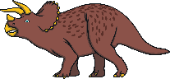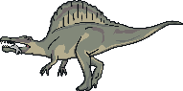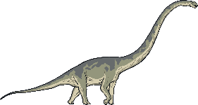

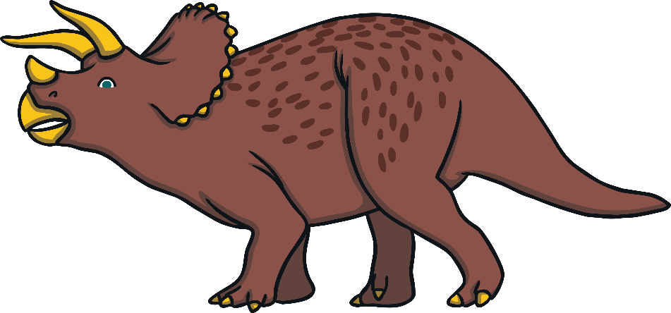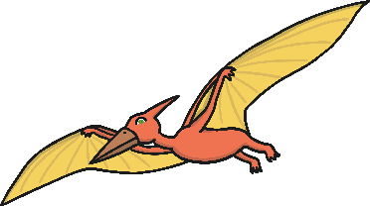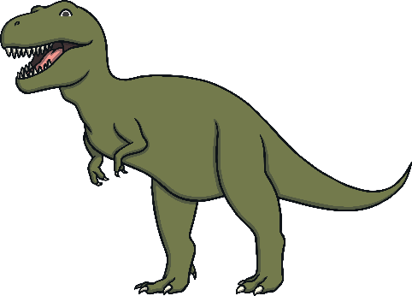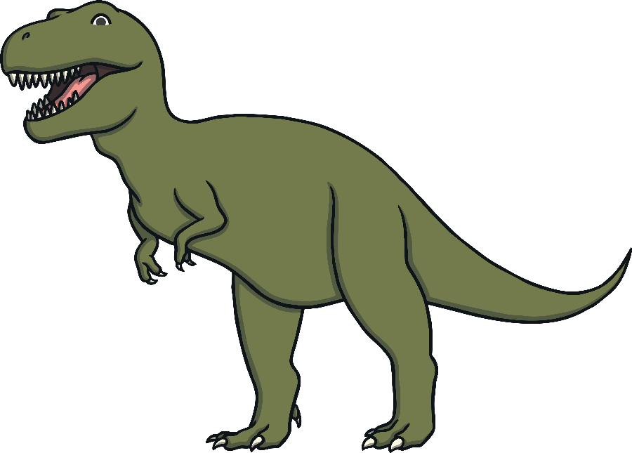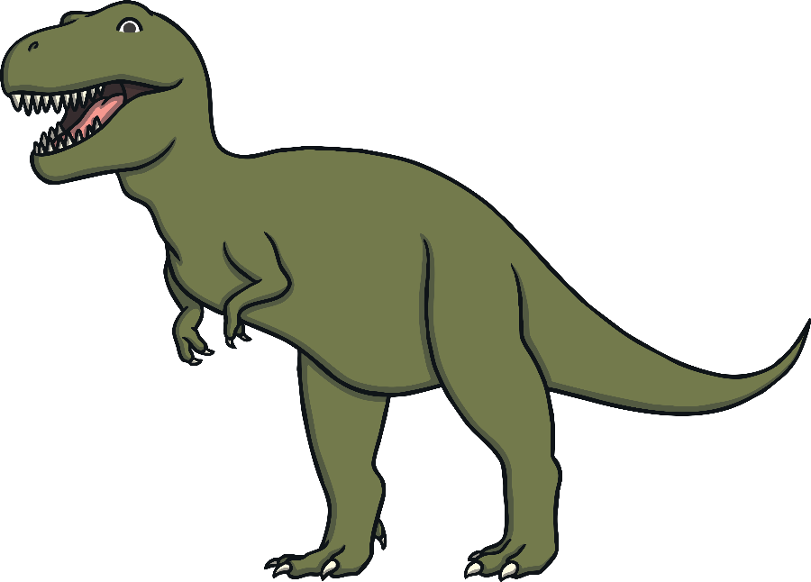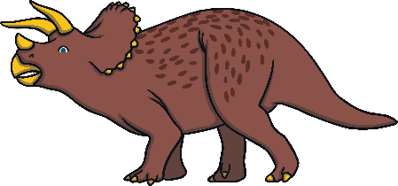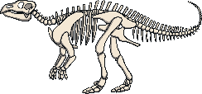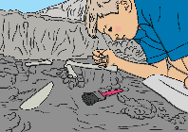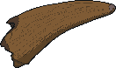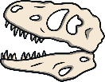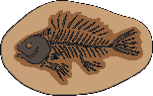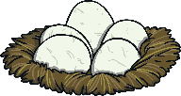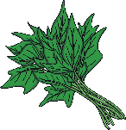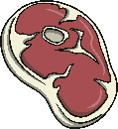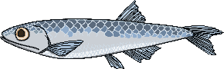

### Diplodocus

### Pterodactyl

**plants**

**meat**

**fish**

**fossils**

### bones

**palaeontologists**

**skeletons**

**teeth**

**eggs**

**horn**

### tail

### wings

**legs**

**claws**

### teeth

### Spinosaurus

**Triceratops**

### Tyrannosaurus rex

**Stegosaurus**

### Stories, songs and rhymes: